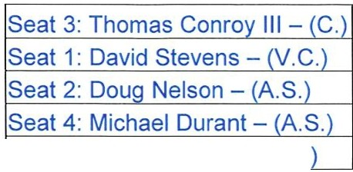

Pine Air Lakes

!Seat 5: Wayne Griest - (A.S.
Community Development District
Revised Agenda

Thursday October 28, 2021
2:00 p.m.
Coleman, Yovanovich & Koester, P.A., Northern Trust Bank Building. 4001 Tamiami Trail North, Suite 300, Naples, Florida 34103 https://global.gotomeeting.com/join/809653605
±1 (872) 240-3212; Access Code: 809-653-605

- Roll Call

- Approval of the Minutes of the September 23, 2021 Meeting

- Acceptance of Commitment Letter with Centennial Bank

- Consideration of Bond Authorizing Resolution 2022-01
  - Exhibit A Form of First Amendment to the 2nd Supplemental Indenture

- Consideration of Allocation Report for the Series 2021 Bond

- Consideration of Engagement Letter with Grau & Associates to perform the Audit for Fiscal Year Ending September 30, 2021

- Staff Reports
  - Attorney

  - Engineer - Discussion of Service Road Repair and Improvement Recommendations

  - Field Report

  - Manager

- Financial Reports
  - Approval of Check Register

  - Balance Sheet and Income Statement

- Supervisors Requests and Audience Comments 10.Adjournment

Meetings are open to the public and may be continued to a time, date and place certain. For more information regarding this CDD please visit the website: http://www.pineairlakescdd.com

